Table of Contents

Total Percent Analysis 2

Kidney Disease 2

Skin Cancer 2

Brain Stroke 2

Age 3

Gender 3

General Health 3

Smoking 4

Asthma 4

Alcohol 4

Diabetes 5

Difficulty Walking 5

Physically Active 5

Physical Health 30-day scale 6

Mental Health 30-day scale 7

Sleep duration 8

# Total Percent Analysis

Total Percent Analysis is based on comparing the percentage ratio of each variable with respect to our prediction result i.e., a Yes/No of the heart disease data. It is a simple and straightforward comparison but it helped us identify the weightage of each question in determining the prediction of heart disease in an individual.

### Kidney Disease

Approximately 29% of the individuals with kidney disease reported heart diseases ranking it at one of the top most risks for heart disease.

### Skin Cancer

### Brain Stroke

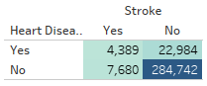

Brain stroke has the highest risk to heart disease amongst all other variables in this data.

### Age



The risk of heart disease is directly proportional to the increase in age.

### Gender

Males are at higher risk of heart diseases than females and more thorough research is needed to answer what causes the difference.

### General Health

The risk of heart disease is directly proportional to the state of general health.

### Smoking

In comparison to Asthma smoking seems to have a slightly higher risk by 0.5% but needs more data to prove this.

### Asthma

### Alcohol

Apparently alcohol doesn’t affect the heart in comparison to other variables, and in fact is one of the lowest risk factors.

### Diabetes

Yes: 22%

Borderline: 11.64%

During Pregnancy: 4.2%

Diabetes seems to play an important role in maintaining a healthy heart.

### Difficulty Walking

Physical activity seems to play a more important role in the outcome of heart diseases in comparison to mental health, but we have to understand the weightage of the survey questions and importance before establishing this firmly.

### Physically Active

### Physical Health 30-day scale

This data determines the number of days an individual is having physical health issues in the last 30 days.

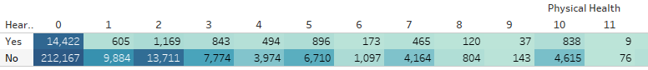

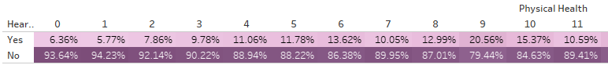

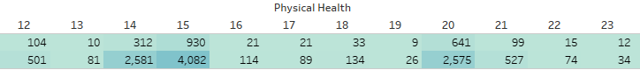

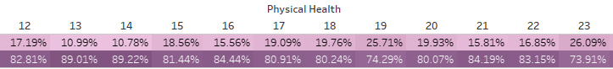

No issues/ 0 days : 6.36%

Consistent issues/ 30 days : 23.68%

### Mental Health 30-day scale

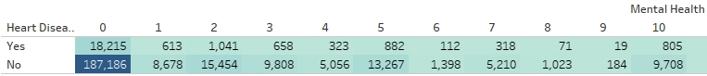

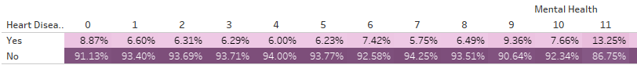

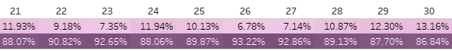

No issues/ 0 days : 8.87%

Consistent issues/ 30 days : 13.16%

Unlike the 30-day physical health scale which shows a clear sign of high co-relation between physical health and heart risk, mental health on the other hand seems to be low in comparison.

### Sleep duration

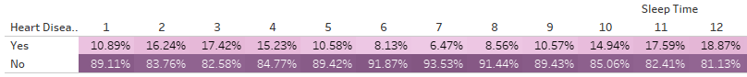

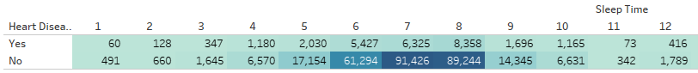

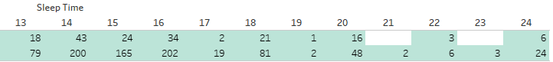

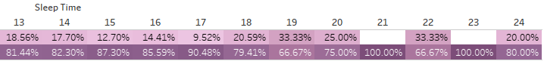

6 hours: 8.13%

7 hours: 6.47%

8 hours: 8.56%

Anything outside the 6-8 hours of sleep shows a higher risk in comparison, and 7 hours of sleep seems to be the best outcome for a healthy heart maintenance.